Asymptotic Notation

# Source:

1. **Asymptotic Notation**

# Khan Academy: [Asymptotic Notation](https://www.khanacademy.org/computing/computer-science/algorithms#asymptotic-notation) learn here nice theory with examples practice here quiz’s

# 

## **Fig: - 1.1** Common Asymptotic Notations

Source: tutorials point

# Introduction to Logarithms:

# [logarithms](https://www.mathsisfun.com/algebra/logarithms.html) refer this very nice introduction about logs.

# 

## **Fig: - 1.2** Basic Log Example

Source: maths is fun

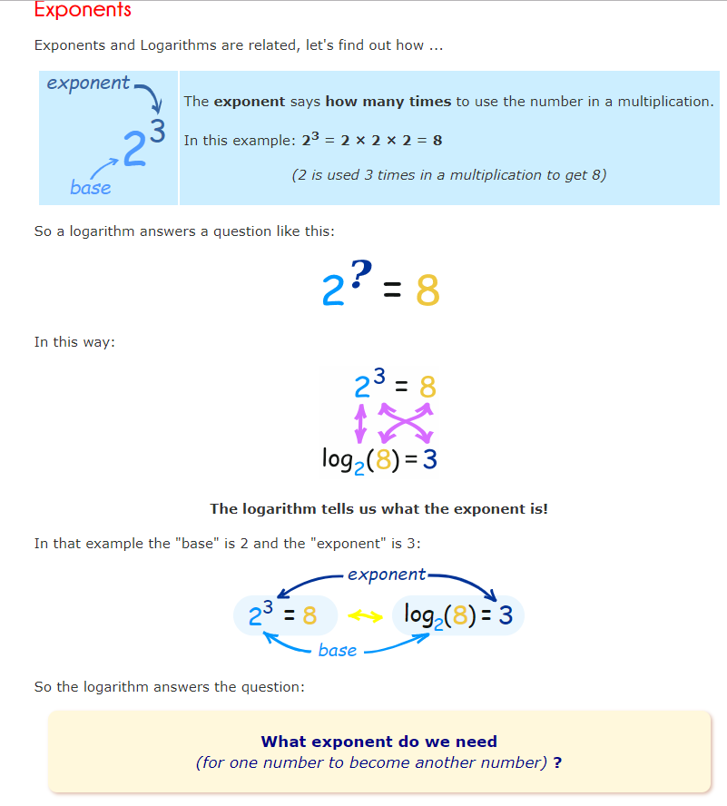

## **Fig: - 1.3** Exponent Log Example

Source: maths is fun

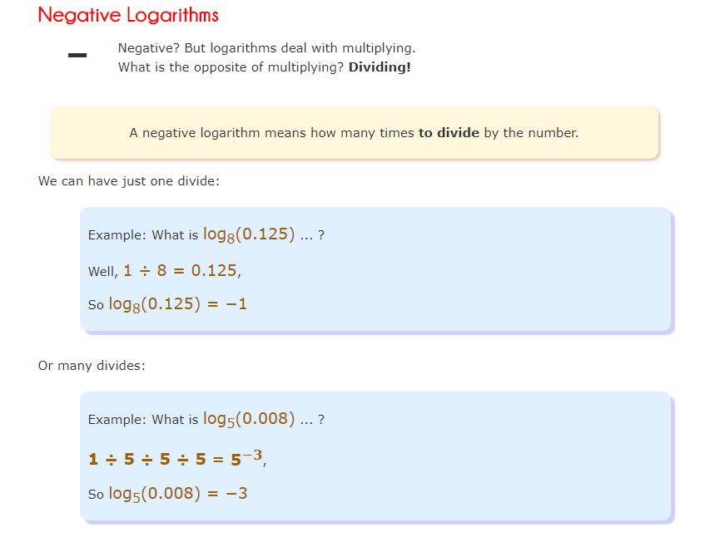

## **Fig: - 1.4** Negative Logs

Source: maths is fun

Quiz source **Khan Academy**

1. Question

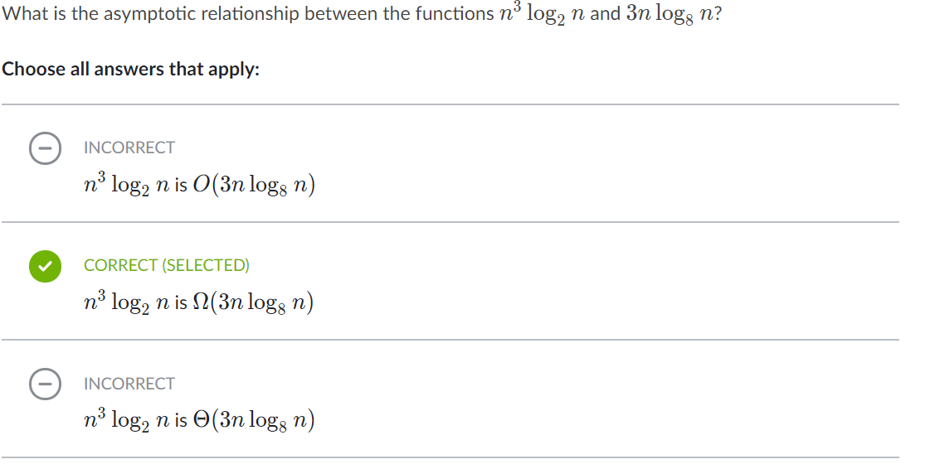

Explanation: -

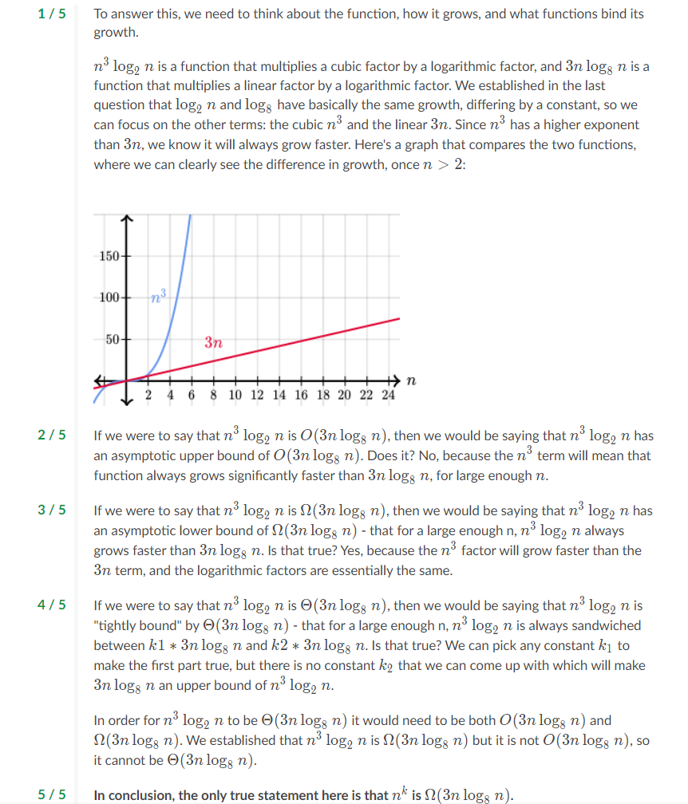

1. Question

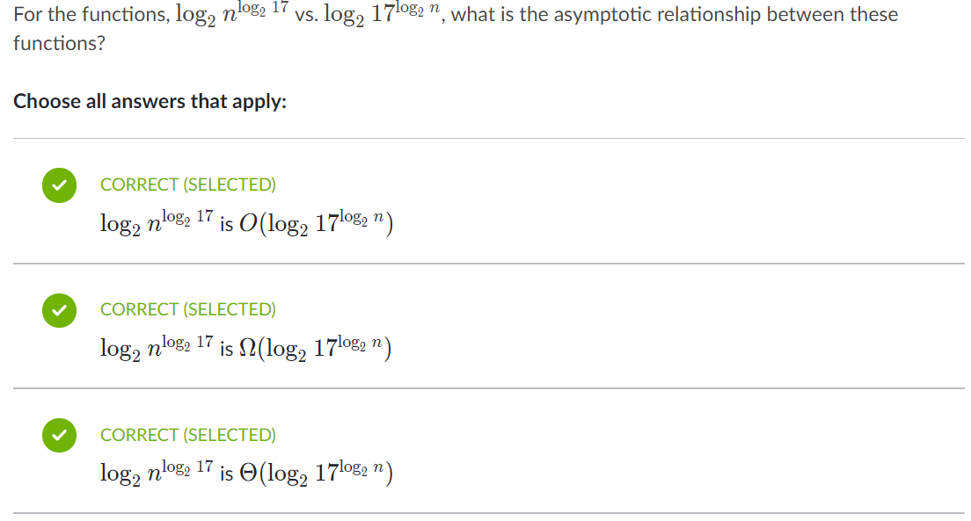

Explanation: -

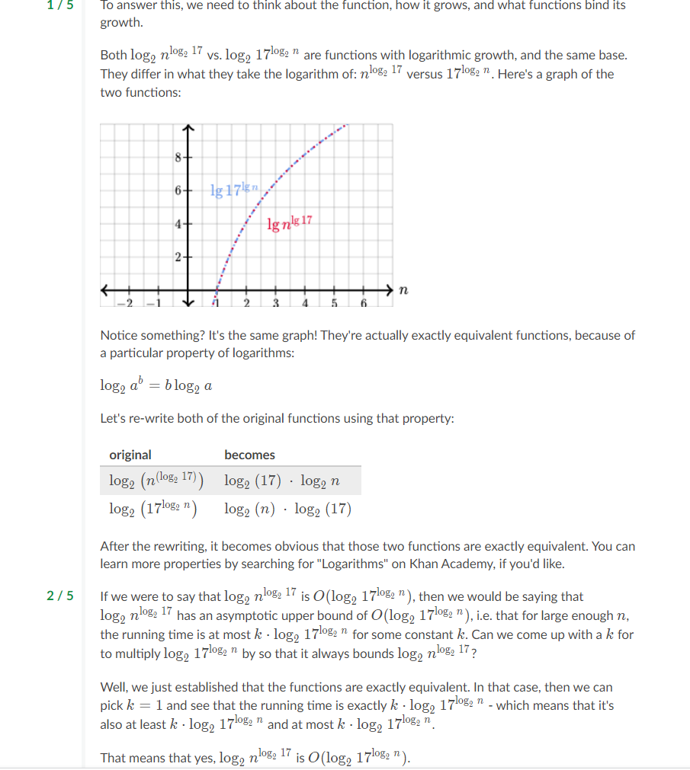

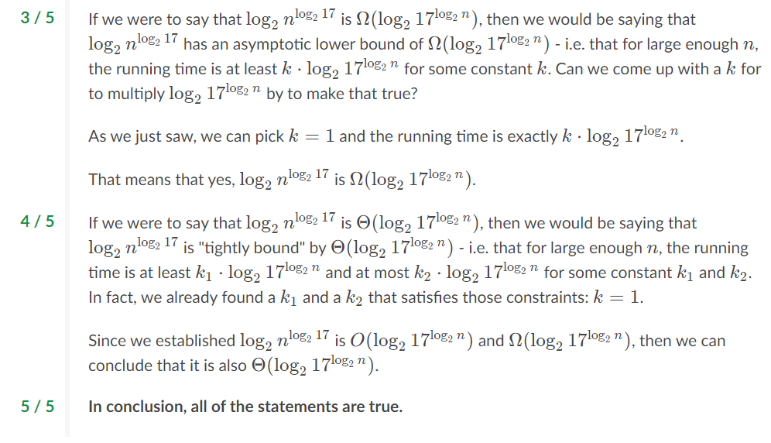

1. Question: -

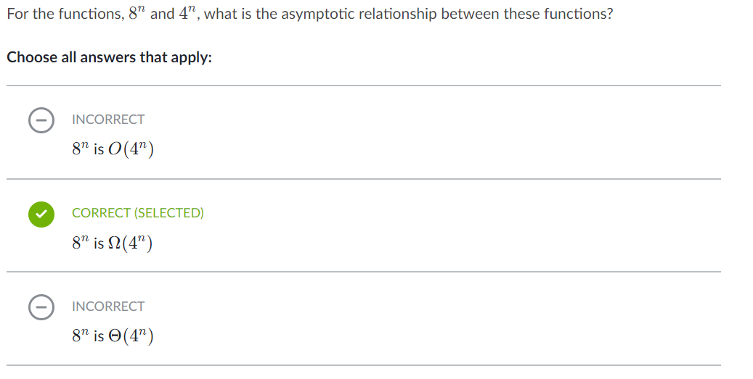

Explanation: -

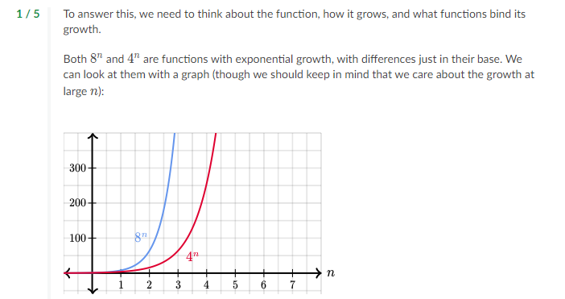

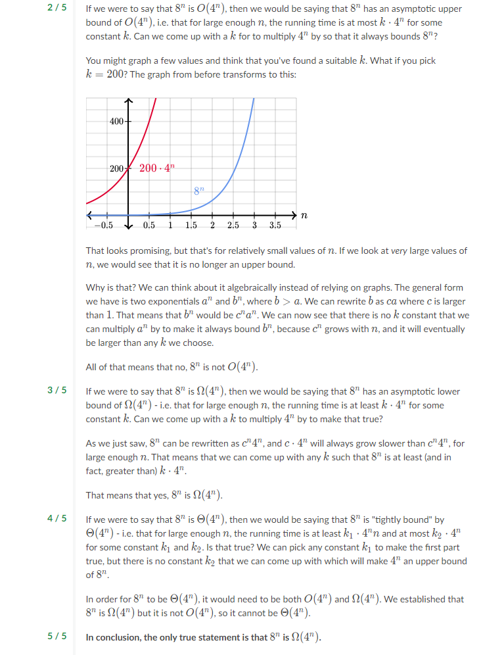

Algorithms from Abdul Bari channel.

1. Intro about course

# Priori Analysis and Posteriori Testing

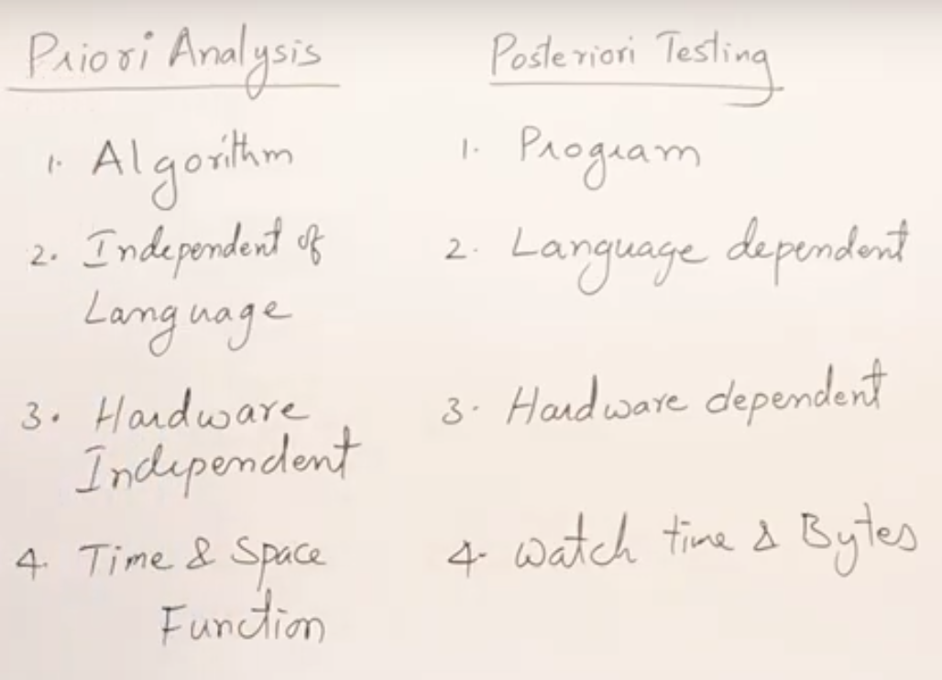

# 1.2 Characteristics of Algorithm

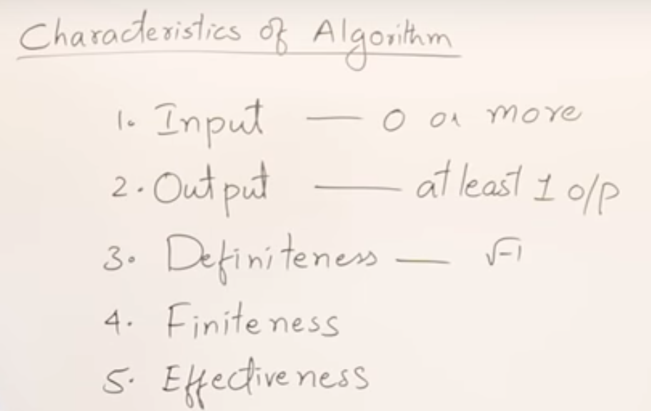

* 0 or more inputs it can have.
* Should have at least one output.
* It should not contain any indeterminate statements like √-1.
* Algorithm must have an end point.
* Don’t write unnecessary statements in it.

# 1.3 How Write and Analyse Algorithm

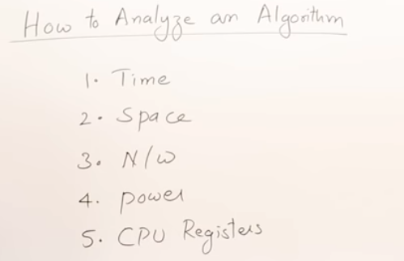

Chrematistics of algorithm.

* Time and space are common.
* If it is n/w-based app how much it is utilising.
* Power basically mobile based apps.
* If it is device driver CPU reg.

Basic time and space analysis

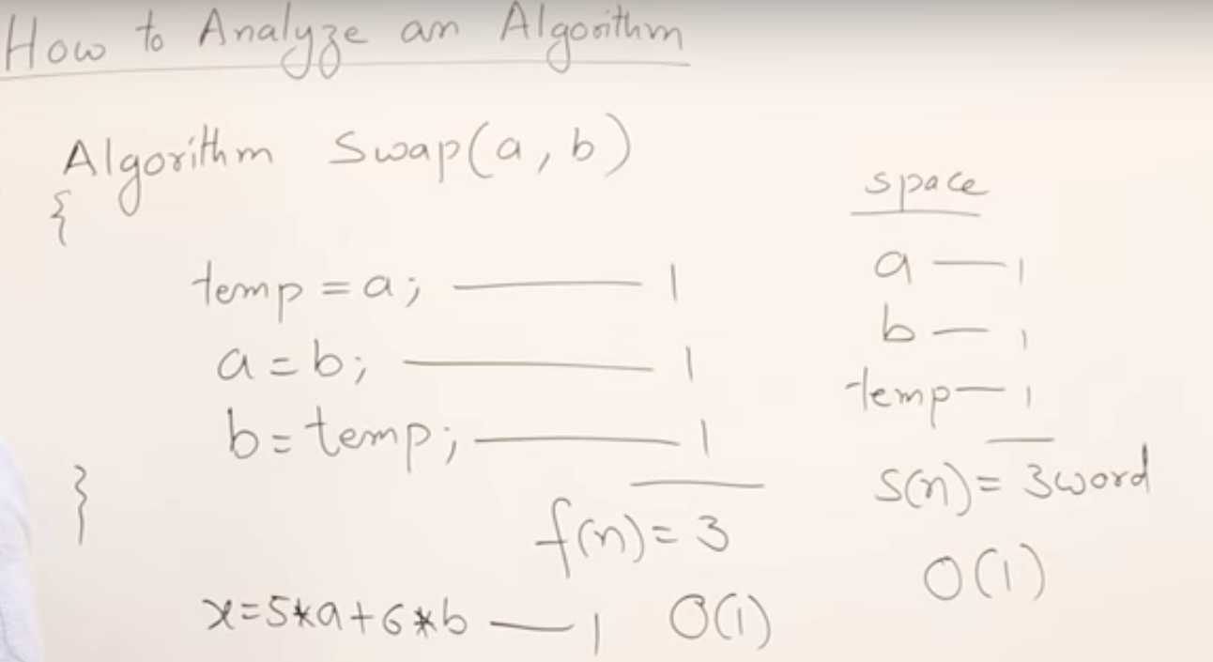

* All simple statements we will consider as 1 unit of time.
* Even if it’s a complex calculation.
* All variables are considered as 1 simple word because we don’t know about its size varies based on its type

# 1.4 Frequency Count Method

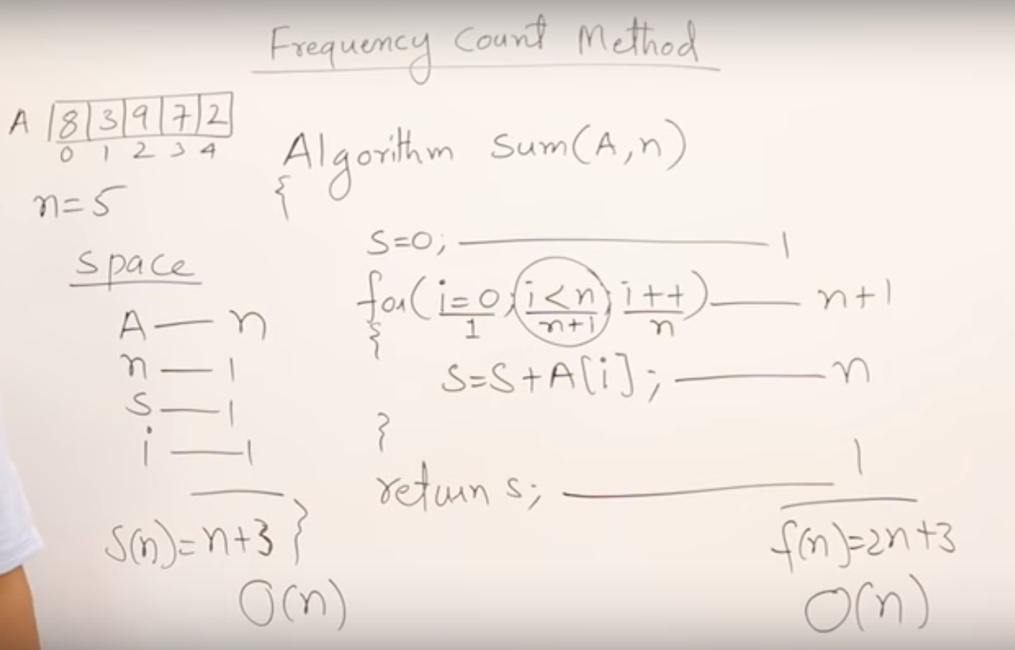

* Sum of an array elements analysis

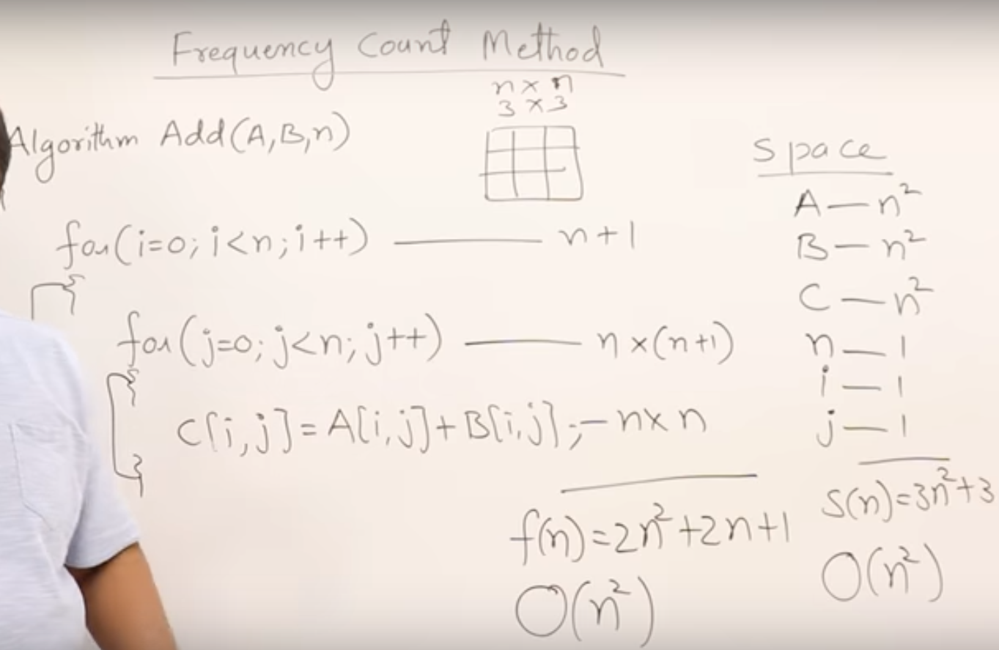

* Sum of two arrays elements analysis

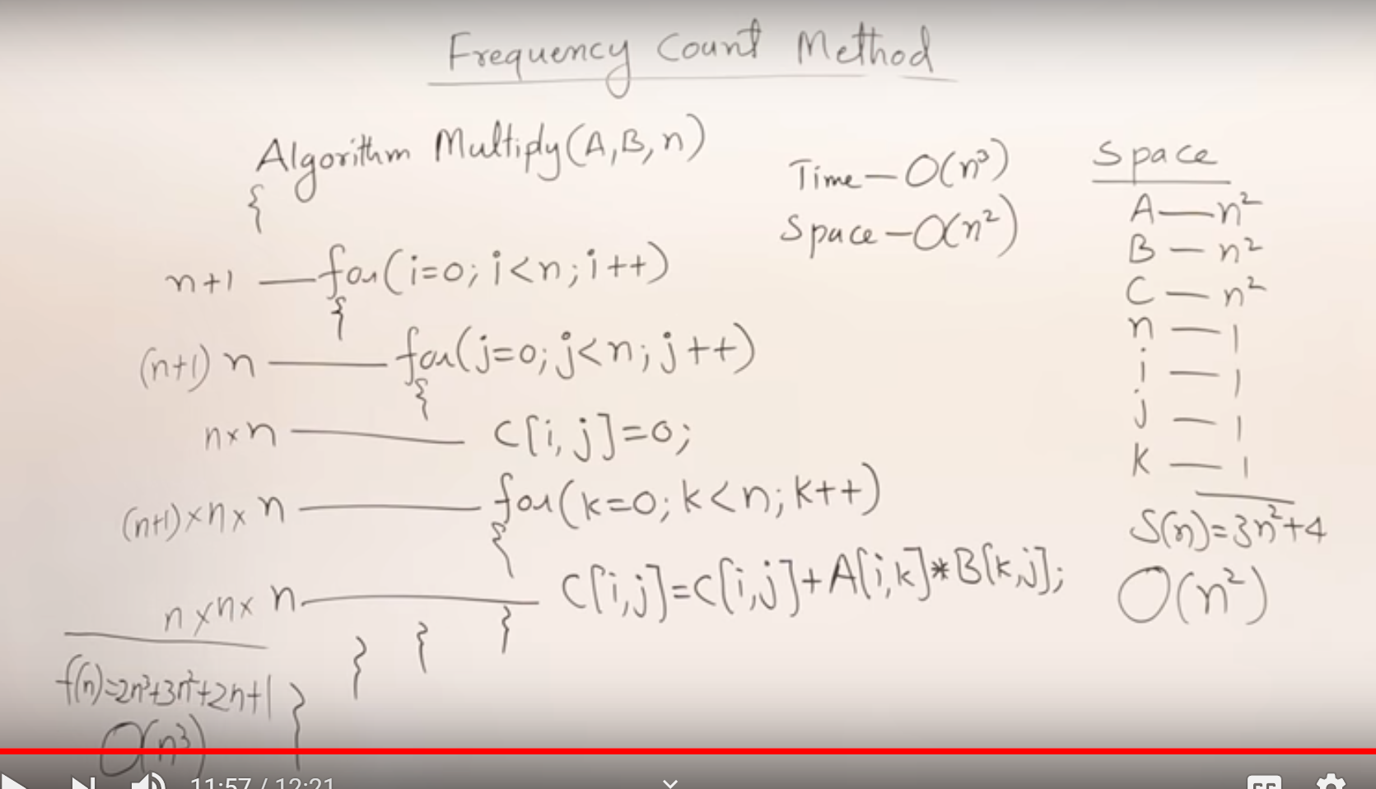

* Multiplication of two arrays elements analysis

1.5.1 Time Complexity #1

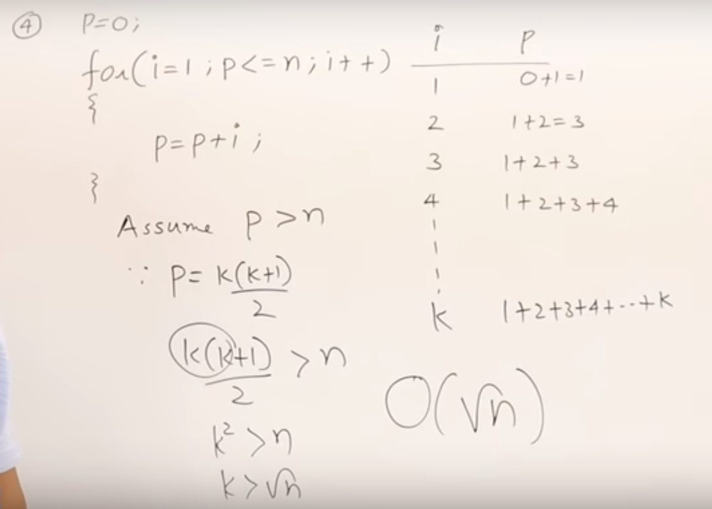

1.5.2 Time Complexity Example #2

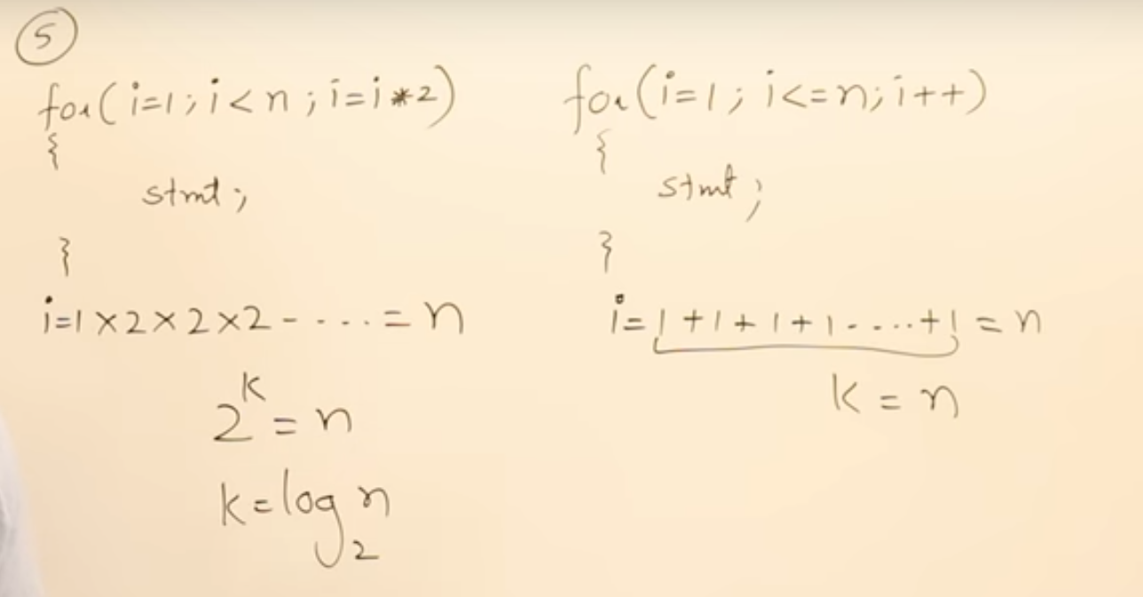

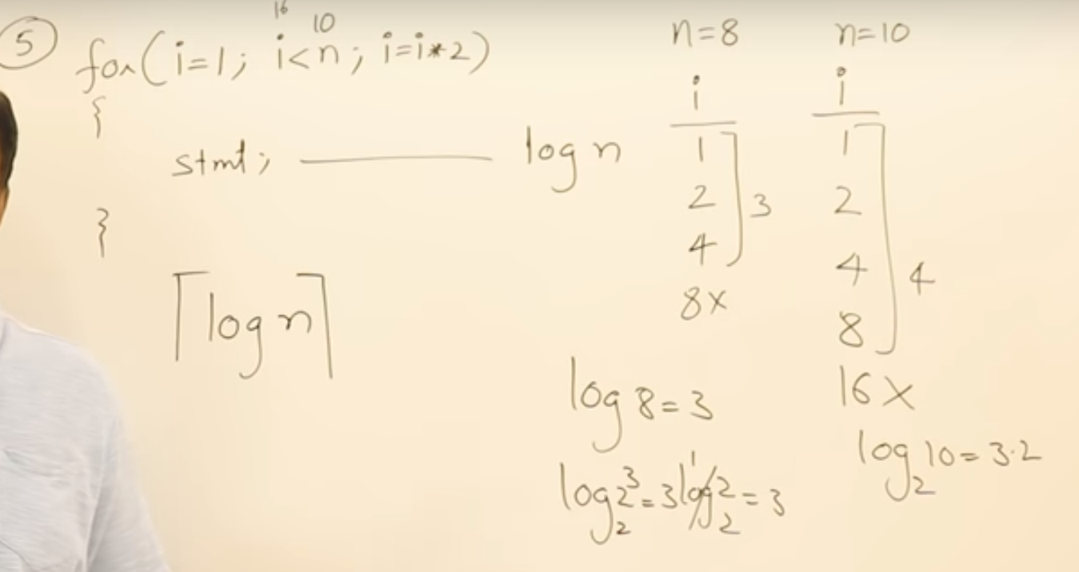

* Log value will be taken as a ceil value
* Observe the difference when n = 8 and n = 10

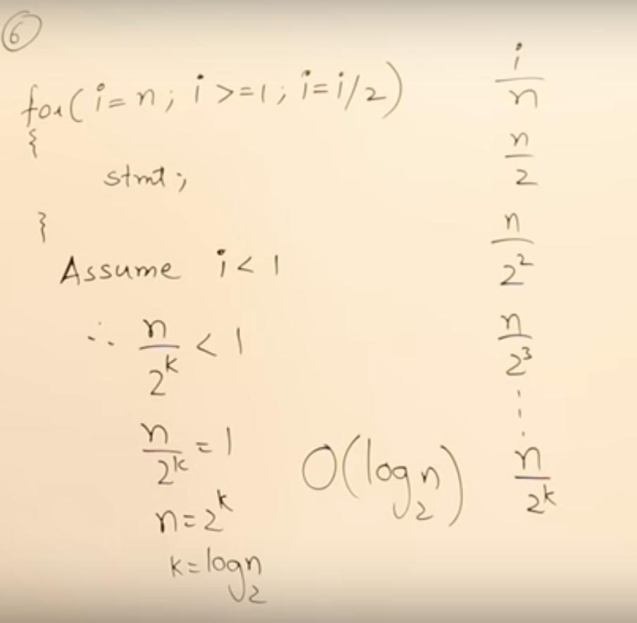

* Multiply or divide by 2 both are **log n**

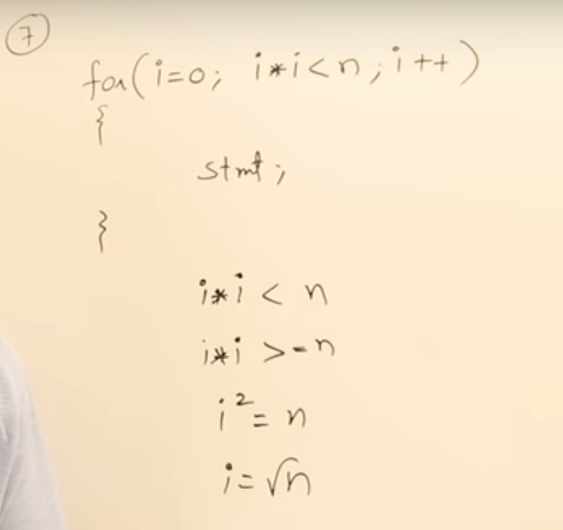

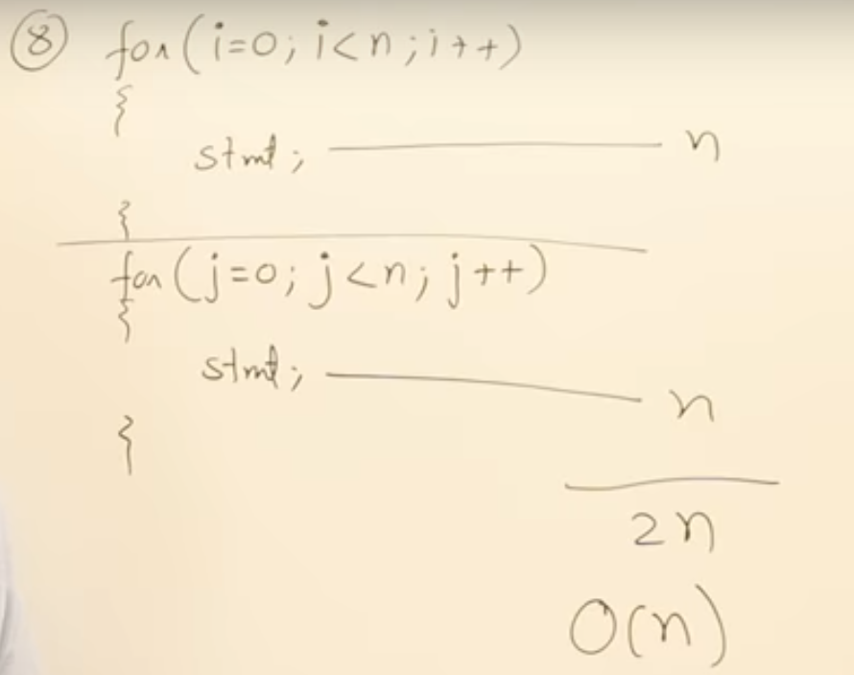

* Analysis of two independent loops

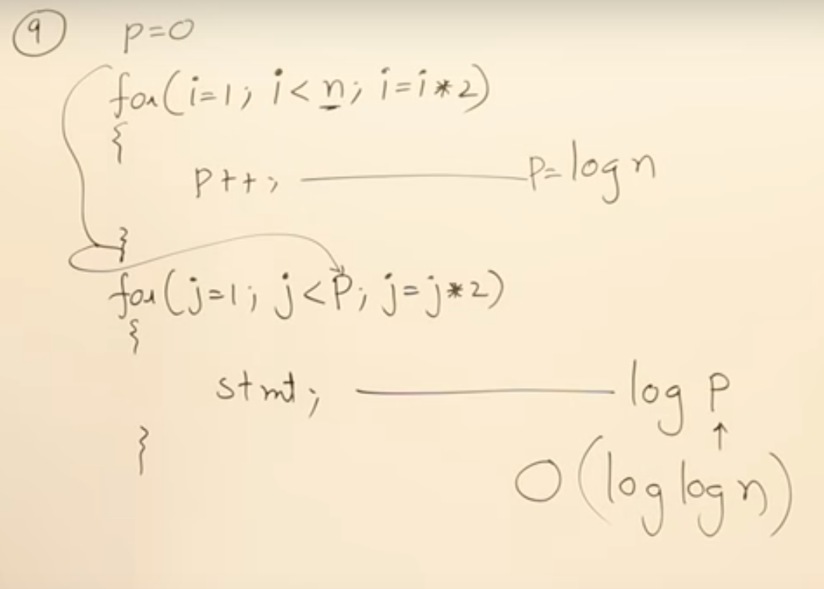

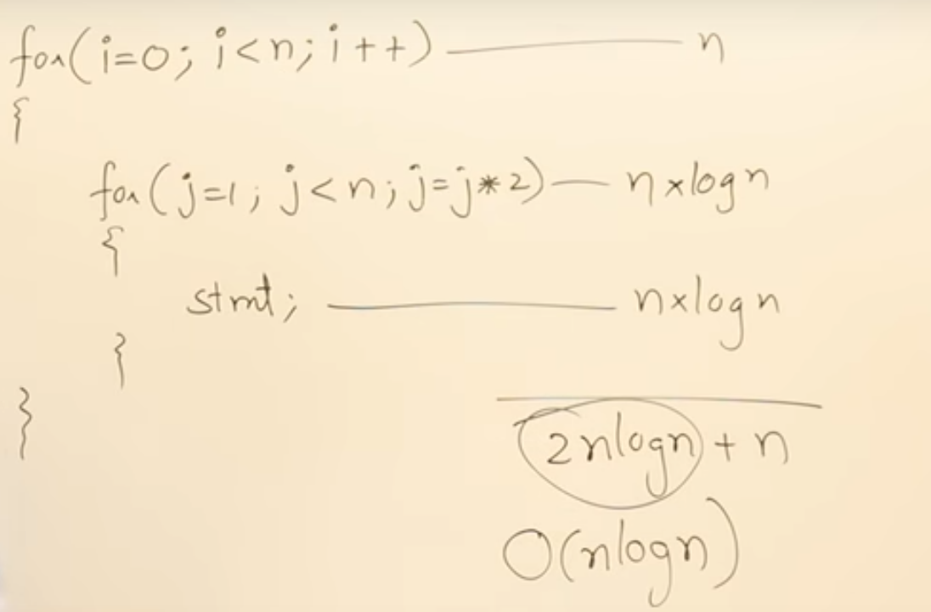

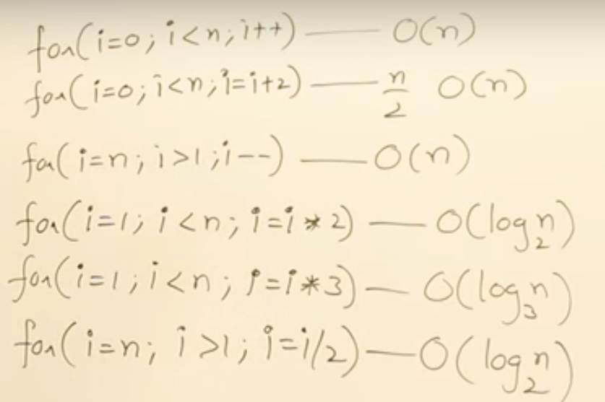

1.5.3 Time Complexity of While and if #3

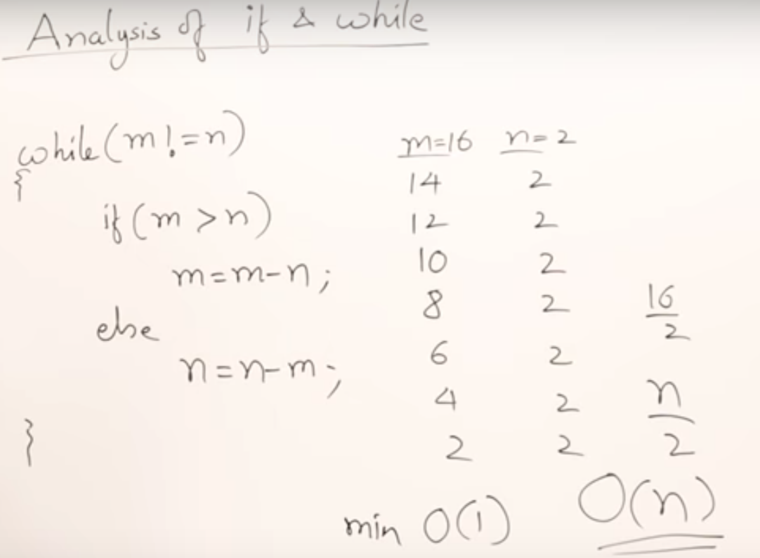

1.8.1 Asymptotic Notations Big Oh - Omega - Theta #1

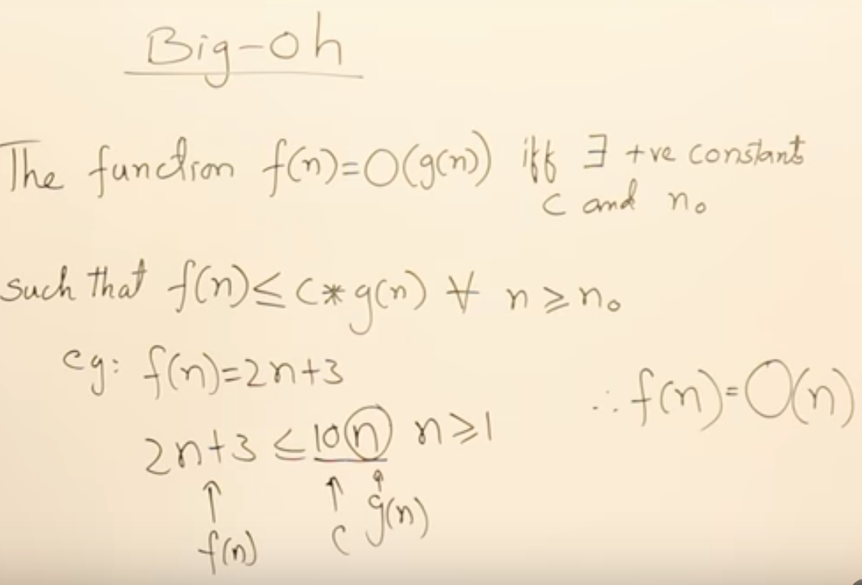

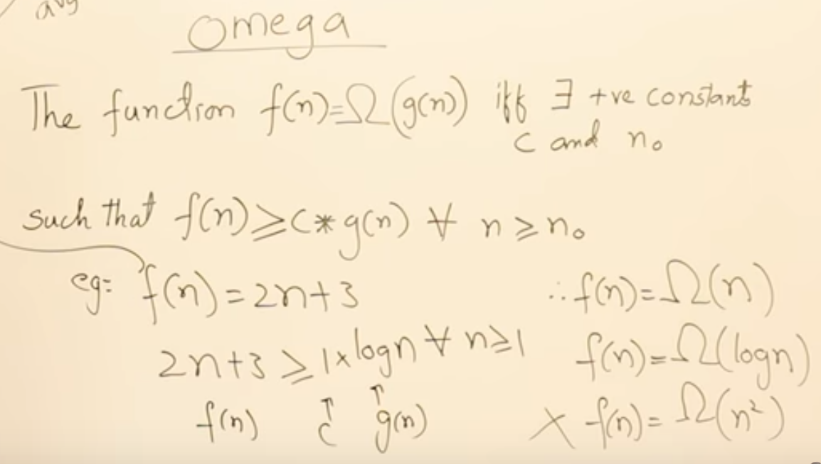

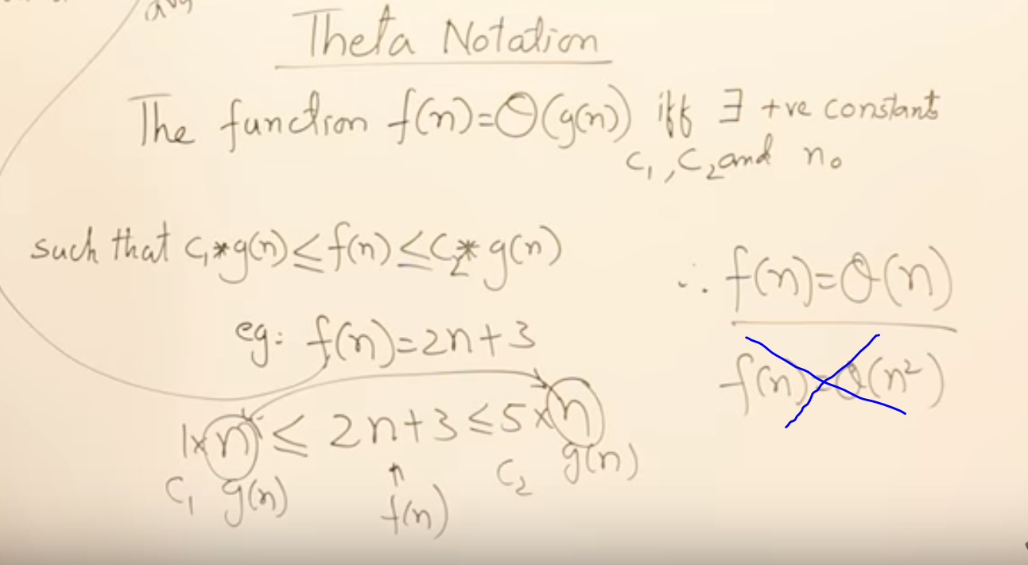

1.8.2 Asymptotic Notations - Big Oh - Omega - Theta #2

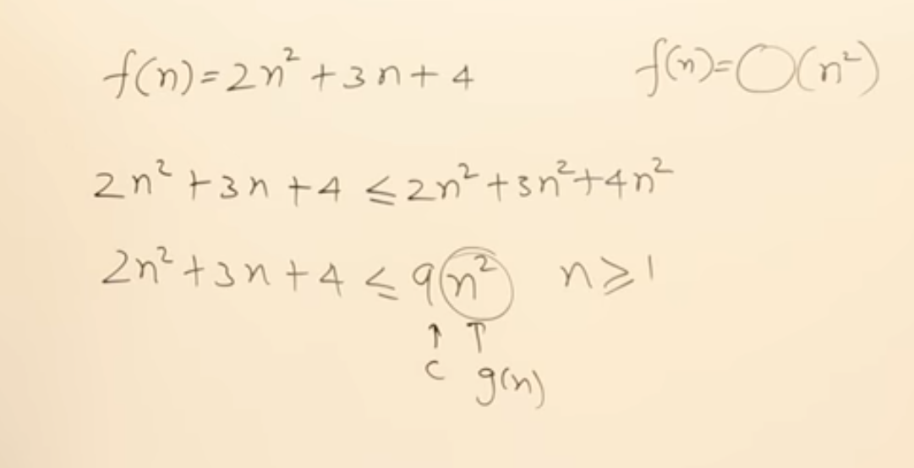

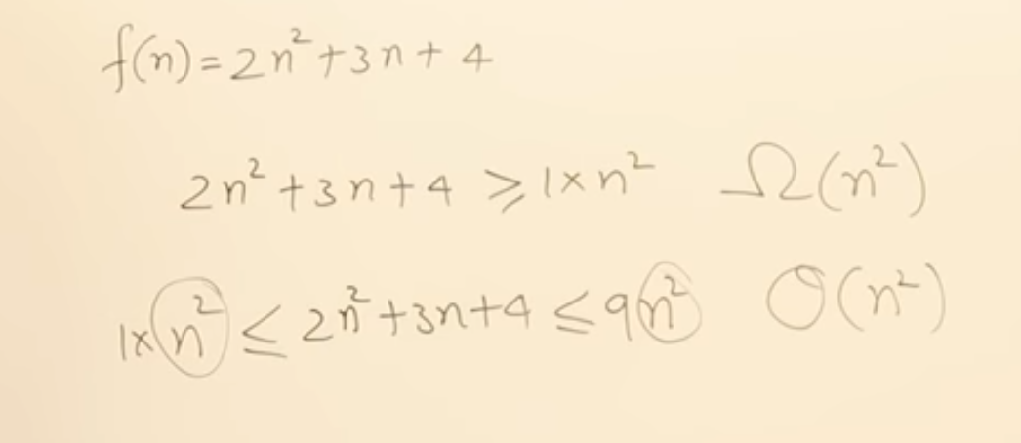

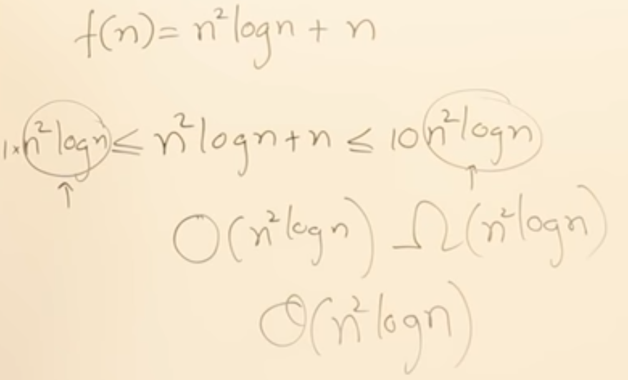

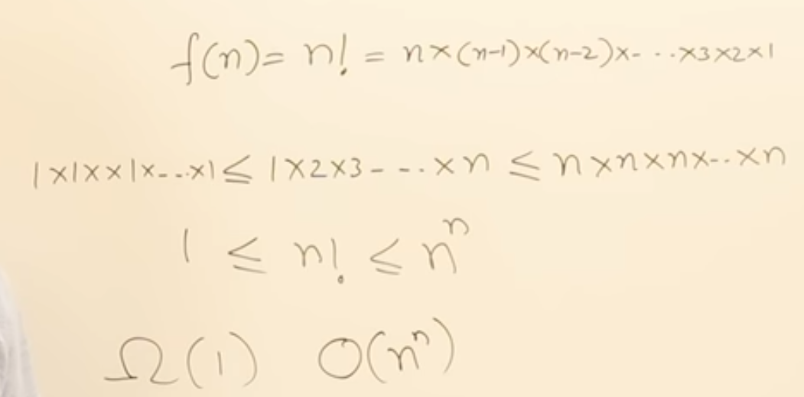

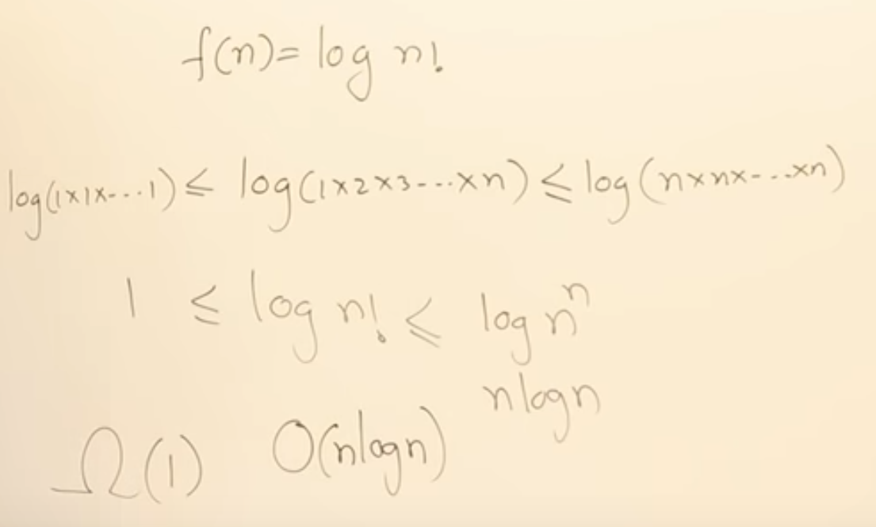

1.9 Properties of Asymptotic Notations

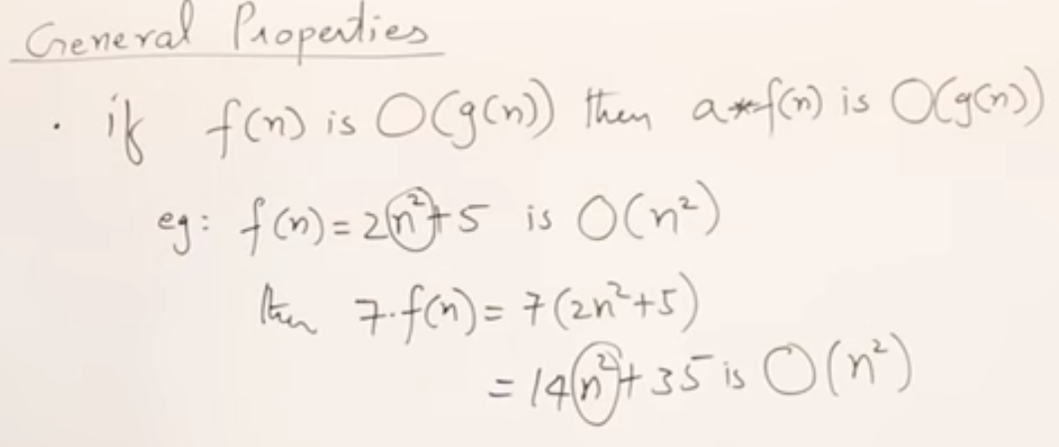

* Same property applied for all 3 notations

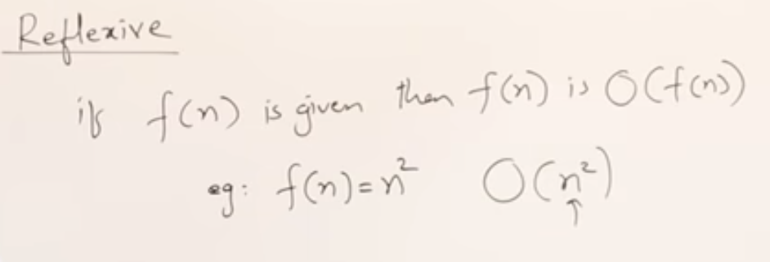

* A function itself upper bound/lower bound read about definitions of notations

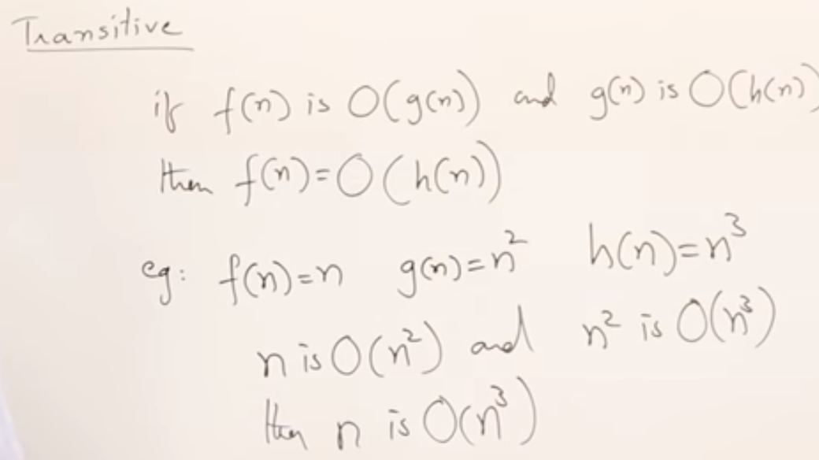

* Same property applied for all 3 notations

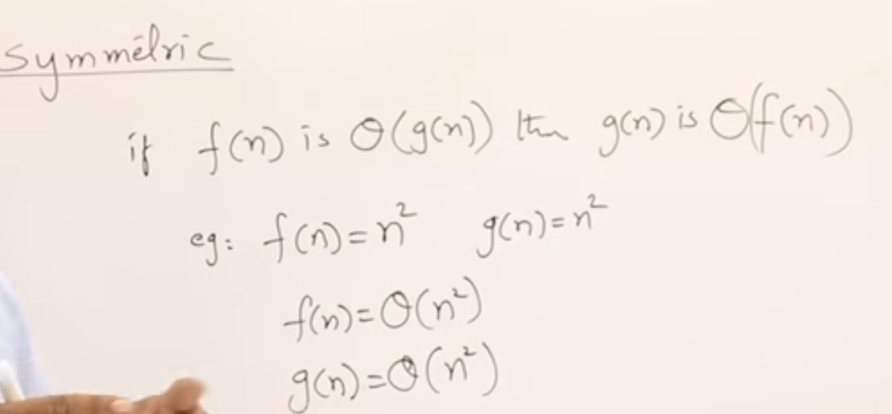

* this property applied for only theta notation

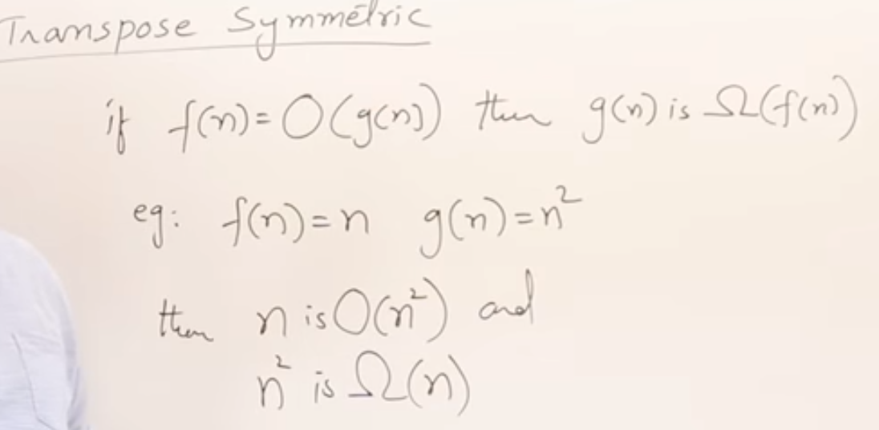

* this property applied for bigh O and theta notation
* Transpose symmetric Theta notion  
  if *f(n) =Ω (g(n)) then g(n) is O(f(n)).*

Examples

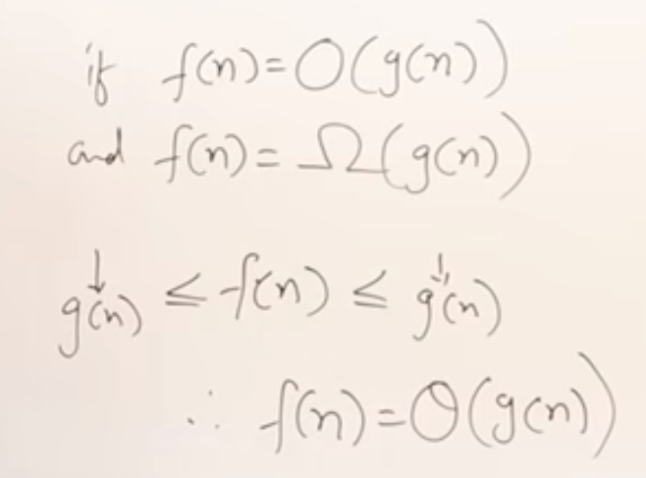

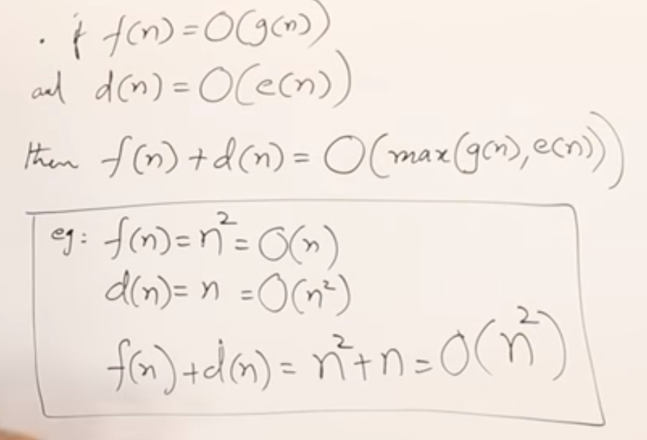

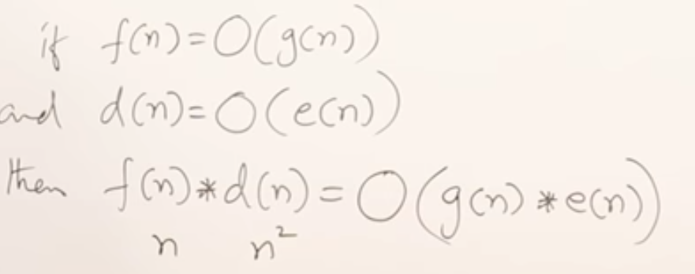

1.10.1 Comparison of Functions #1

How we can compare two functions to represent in asymptotic notations.

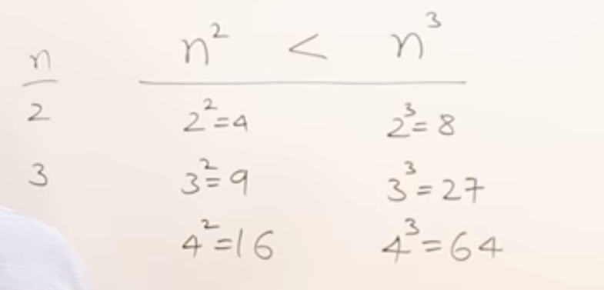

* Sample some values into function to know which function is greater or less

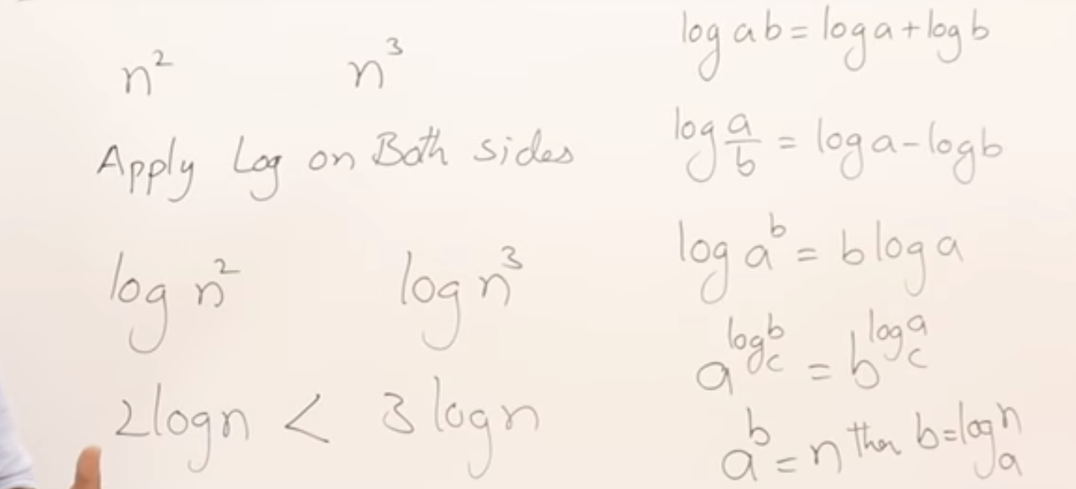

* Apply *log* on both sides

Example

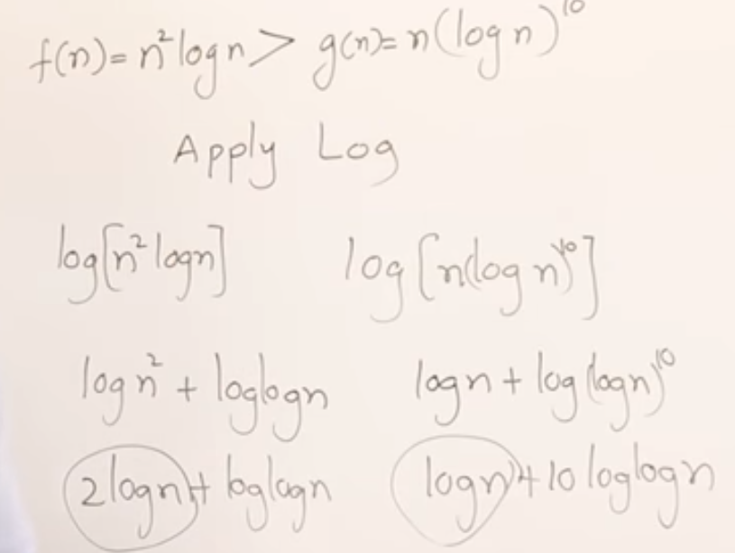

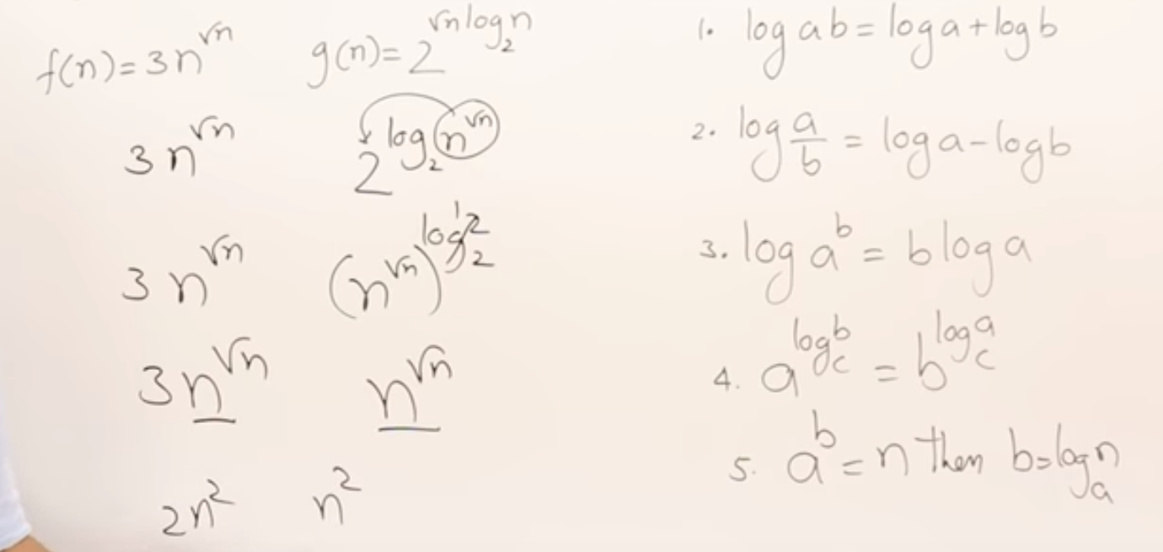

1.10.2 Comparison of Functions #2

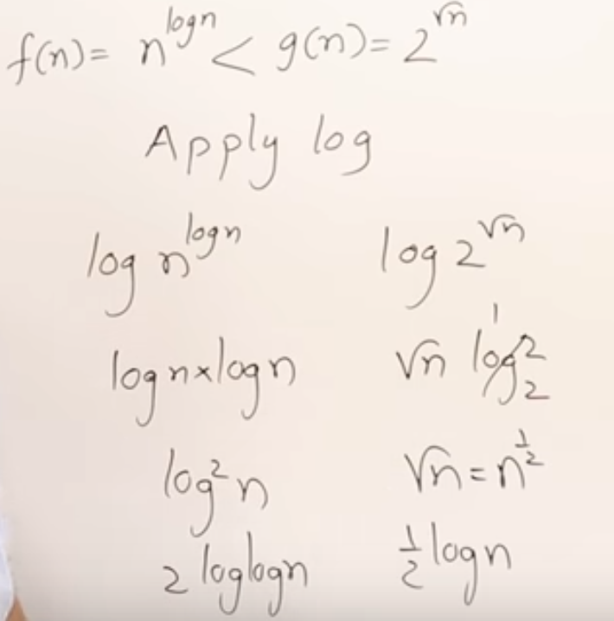

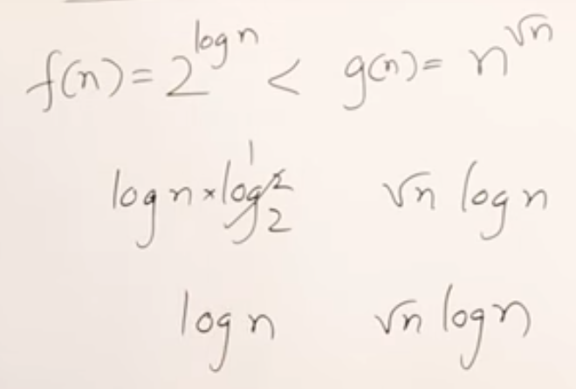

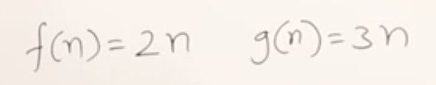

* These are equal

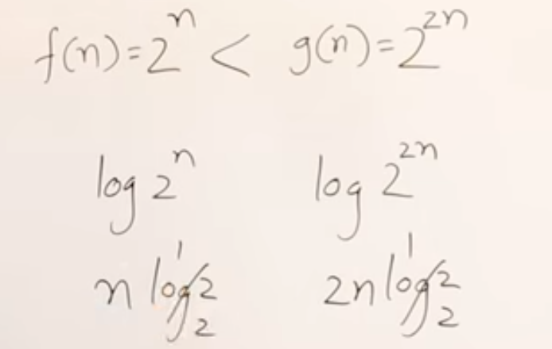

* After applying the log based on the result, we will say 2^2n is greater.
* Don’t ignore the coefficients after applying the log.

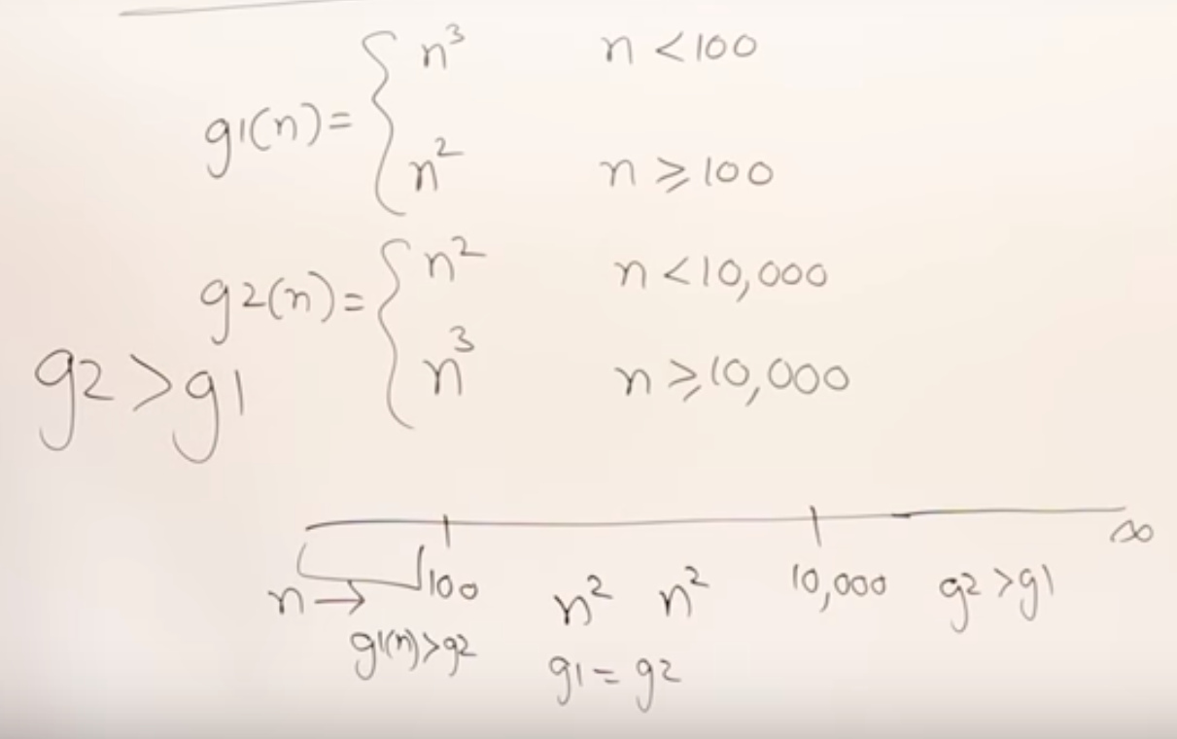

* We will always consider n for large values.